

Stonefield Homes, LLC

Commercial insurance proposal

Presented by: Kyle L Cardwell  
kcardwell@swinglecollins.com

(972) 387-6739

13760 Noel Road, Suite 600

Dallas, TX 75240

Table of Contents

Why Choose Swingle Collins? 3

Your Trusted & Knowledgeable Advisors 4

Thorough & Accurate Coverage 5

Workers Compensation 6

Additional Coverage to Consider 9

Premium Summary 10

We’re Here for You 24/7 11

Why Choose Swingle Collins?

As one of the largest privately-owned insurance agencies in Texas, Swingle Collins & Associates is able to provide solutions for even the most unique and complex risks. Our status as an independent firm allows us to offer the type of tailored service and coverage options that our clients both expect and deserve.

Because of our growth, success and level of service, leading carriers have awarded us top-tier access, which directly benefits our clientele with a broader range of choices and services. By adopting a consultative approach and staying at the forefront of emerging trends, we’re able to deliver options that are selected specifically to ensure that your business, assets, family, and employees have the level of coverage they need.

Our elite team of risk advisors is considered best-in-class by industry peers and clients alike. We’ve been named a Top 100 Independent Property/Casualty Agency by *Insurance Journal* and rated among the “Best Places to Work” by *Insurance Journal* and the *Dallas Business Journal*.

In everything we do, we strive to be an extension of your company and family wealth management team, providing you with the peace of mind that your assets are properly protected — and that your needs will always come first.

Your Trusted & Knowledgeable Advisors

|  |  |  |
| --- | --- | --- |
|  |  | Personal Risk Advisor |
|  |  | *Your coverage expert and partner.* |
|  |  | **Kyle L Cardwell, CLCS, MSM** |
|  |  | (972) 387-6739 |
|  |  | kcardwell@swinglecollins.com |
|  |  |  |

|  |  |  |
| --- | --- | --- |
|  |  | Account Manager |
|  |  | *Provides support for claims, billing, and coverage questions.* |
|  |  | **Erin Grady, MBA, CISR** |
|  |  | (972) 715-8775 |
|  |  | egrady@swinglecollins.com |
|  |  |  |

|  |  |  |
| --- | --- | --- |
|  |  | Assistant Account Manager |
|  |  | *Supports the team and will often contact you to follow up on  outstanding items, billing, and renewals.* |
|  |  | **Jessica Staggs** |
|  |  | (972) 715-8779 |
|  |  | jstaggs@swinglecollins.com |
|  |  |  |

|  |  |  |
| --- | --- | --- |
|  |  | Certificate and Evidence of  Property REquests |
|  |  |  |
|  |  | **Services Department** |
|  |  | services@swinglecollins.com |
|  |  |  |

Thorough & Accurate Coverage

Our goal is to make sure that you always have adequate coverage in place for your family, your assets, and your business. That’s why it’s important to contact us when there are any changes that may have a bearing on your insurance program. Your insurers evaluate and accept risks on the basis of the information you’ve given; any outdated information could lead to complications in the event of a loss.

* **These changes may include, but are not limited to:**
* Change of mailing and/or billing address.
* Changes in your personnel who are responsible for insurance decisions.
* Personnel traveling overseas, on temporary assignment overseas, or working on military bases.
* Acquisitions, creation of new companies or subsidiaries, and/or mergers in which you are involved, or that change the legal corporate structure in any way.
* Purchase, construction, or occupancy of new premises, either foreign or domestic. This includes alteration, vacating the premises, temporary inoccupancy, or extension or demolition of existing premises.
* Increase in the value of a building or business personal property, for both scheduled and unnamed locations.
* Transfer of business personal property, inventory, or stock to a new or temporary location.
* Any addition of new locations, equipment, or vehicles, whether they are hired, leased, or borrowed.
* Changes in processes, occupancy, products, or business operations.
* Addition, alteration or temporary disconnection of fire or burglary protection systems.
* Use of aircraft or watercraft, whether or not you own them.
* Major changes in the value or nature of goods being shipped.
* Employment of personnel in states in which you were previously not doing business.
* Election or appointment of a new CEO or COO, or any change in control of either the company’s Board of Directors or stock ownership.
* Changes in ERISA Plan Assets.
* Addition of new drivers for the company.
* Insurance requirements for a lease or business contract that require additions or changes to your existing coverage.

Workers Compensation

|  |  |
| --- | --- |
| **Issuing Company** | **Texas Mutual Insurance Co** |
| **Policy Number** | **0001285647** |
| **Policy Term** | **4/7/2023 to 4/7/2024** |

Named Insureds

| Insured | Interest |
| --- | --- |
| Stonefield Homes, LLC | First Named Insured |
| Phillip Jennings Custom Homes LTD | Additional Named Insured |
| Stonefield Homes, Inc. | Additional Named Insured |

Coverages

|  |  |
| --- | --- |
| Description | Limit |
| Employers Liability: Each Accident | $1,000,000 |
| Employers Liability: Disease – Policy Limit | $1,000,000 |
| Employers Liability: Disease – Each Employee | $1,000,000 |
| Workers Compensation: Statutory Benefit | Included |
| 3A Coverage | Texas |
| 3C Coverage | N/A |

Locations & Class Codes

| Loc | | St | | Code | | Description | | Estimated Annual Payroll | | Base Rate | | Estimated Annual Premium |
| --- | --- | --- | --- | --- | --- | --- | --- | --- | --- | --- | --- | --- |
| **1** | **5001 LBJ Freeway, Suite 850• Dallas, TX 75244** | | | | | | | | | | | |
|  | TX | | 5403 | | Carpentry - Private One Or Two Family Residences | | If Any | | 6.89 | | $0 | |
|  | TX | | 5606 | | Contractor - Executive Supervisor | | $199,707 | | 1.04 | | $2,077 | |
|  | TX | | 8742 | | Salespersons - Outside | | If Any | | 0.32 | | $0 | |
|  | TX | | 8810 | | Clerical Office Employees | | $124,849 | | 0.16 | | $200 | |

Premium Calculations

| Description | | Factor | | Factored Premium |
| --- | --- | --- | --- | --- |
| Estimated Manual Premium | |  | | $2,277.00 |
| Blanket Waiver of Subrogation | | 0.02 | | $46.00 |
| Increased Limits Factor | | 0.014 | | $32.00 |
| Increased Limits Balance to Minimum Premium | |  | | $118.00 |
| Premium Incentive for Small Employer Modifier | | 0.85 | | ($371.00) |
| Schedule Modifier | | 0.86 | | ($294.00) |
| Healthcare Network Option | | 0.12 | | ($217.00) |
| Expense Constant | |  | | $150.00 |
| TOTAL Estimated Premium | |  | | $1,741.00 |
|  |  | |  | |

Included / Excluded Individuals

| Name | Title | Included | Excluded |
| --- | --- | --- | --- |
| Heidi Fristoe - Loc 1 | Partner Spouse |  | X |

Forms and Endorsements

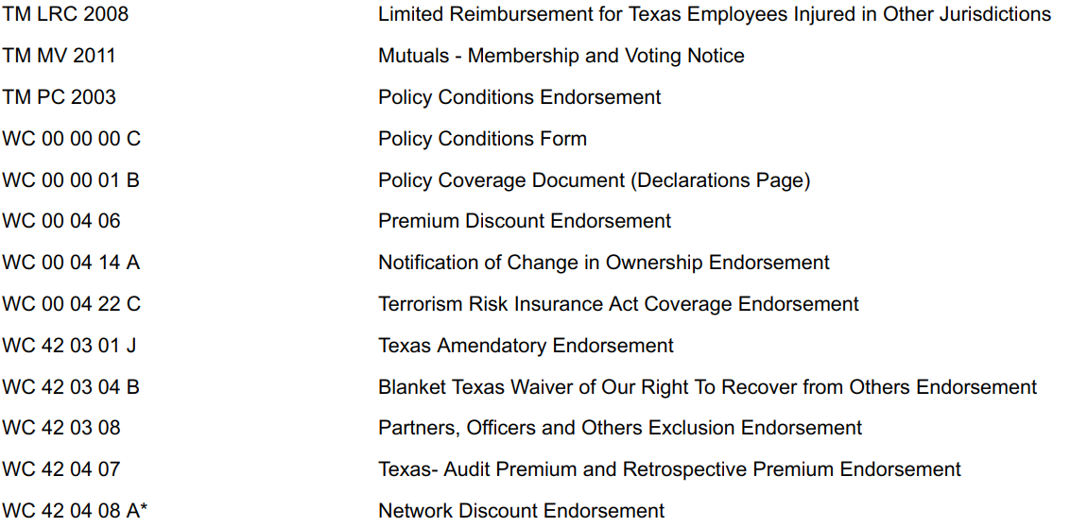

**Dividend History**

| Year | Individual Dividends |
| --- | --- |
| 2022 | $855.27 |
| 2021 | $712.50 |
| 2020 | $1,243.54 |
| 2019 | $1,067.30 |
| 2018 | $823.79 |
| 2017 | $274.15 |
| 2016 | $184.22 |
| TOTAL | $5,160.77 |
|  |  |

Additional Coverage to Consider

Below is a list of coverages for your consideration:

* Accident
* Bonds
* Builders Risk
* Business Income (Loss of Income and Extra Expense)
* Cargo
* Crime
* Cyber Liability
* Deductible Buy Back
* Dependent Property
* Directors & Officers Liability
* Earthquake
* Employed Lawyer
* Employee Benefits Liability
* Employment Practices Liability
* Fiduciary Liability
* Flood
* Foreign Liability or Travel Insurance
* Group Excess
* Higher Liability Limits
* Inland Marine
* Kidnap and Extortion
* Pollution Liability
* Professional Liability
* Trade Credit
* Transit
* Workplace Violence

Premium Summary

|  |  |  |
| --- | --- | --- |
| Coverage | Expiring Premium | Renewal Premium |
| Workers Compensation | $1,800.00 | $1,741.00 |
| **Grand Total** | **$1,800.00** | **$1,741.00** |

Payment Options

|  |  |  |
| --- | --- | --- |
| Down Payment Amount | Check Payable to | # of Reports |
| $574.53 | Texas Mutual Insurance Company | 3 |

*This proposal is provided as an overview of your policy. You must refer to the provisions found in your policy for the details of your coverage, terms, conditions, and exclusions that apply.*

We’re Here for You 24/7

We place a high priority on providing superior service, and on being there for you whenever you need us. We’re always happy to take your calls, answer emails and resolve any issues during standard business hours. Outside office hours, we make it easy to get the information you need with 24/7 account access through your computer or device.

Whether at your office, at home, or on the road you can log into your account anytime, anywhere to:

* Review your coverage and current policy information.
* Request changes to your policies or contact information.
* Create and send certificates of insurance and auto ID cards on demand.
* Report a claim or loss

Your time is valuable. Our goal is to help you quickly and easily get the information or resources you need, whether you’re dealing with us in person, on the phone or online

